CSD3156 Lab1 Report

Student Name: Bryan Ang Wei Ze
Student ID: 2301397

Result 1: Please paste the screenshot in the box below.
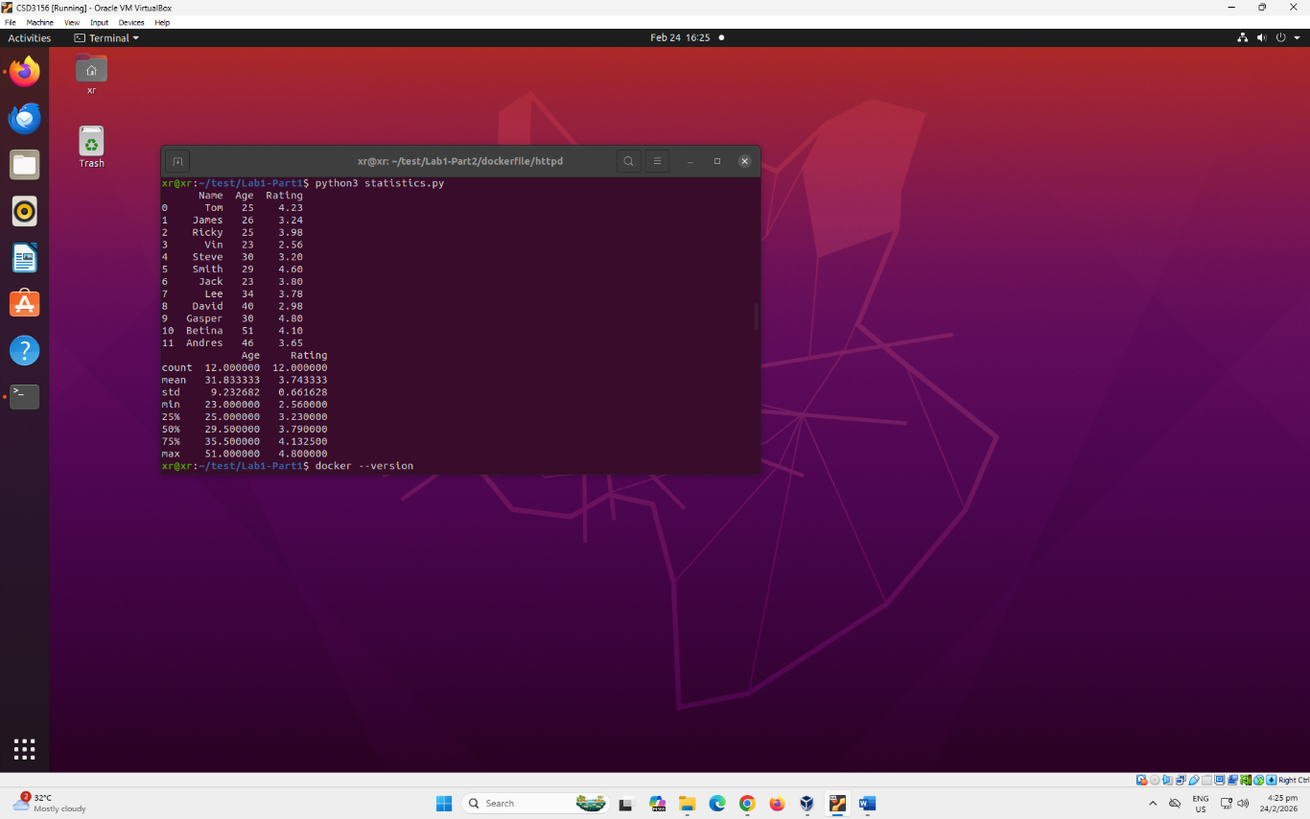

Result 2: Please paste the screenshot in the box below.
sudo docker images
sudo docker ps
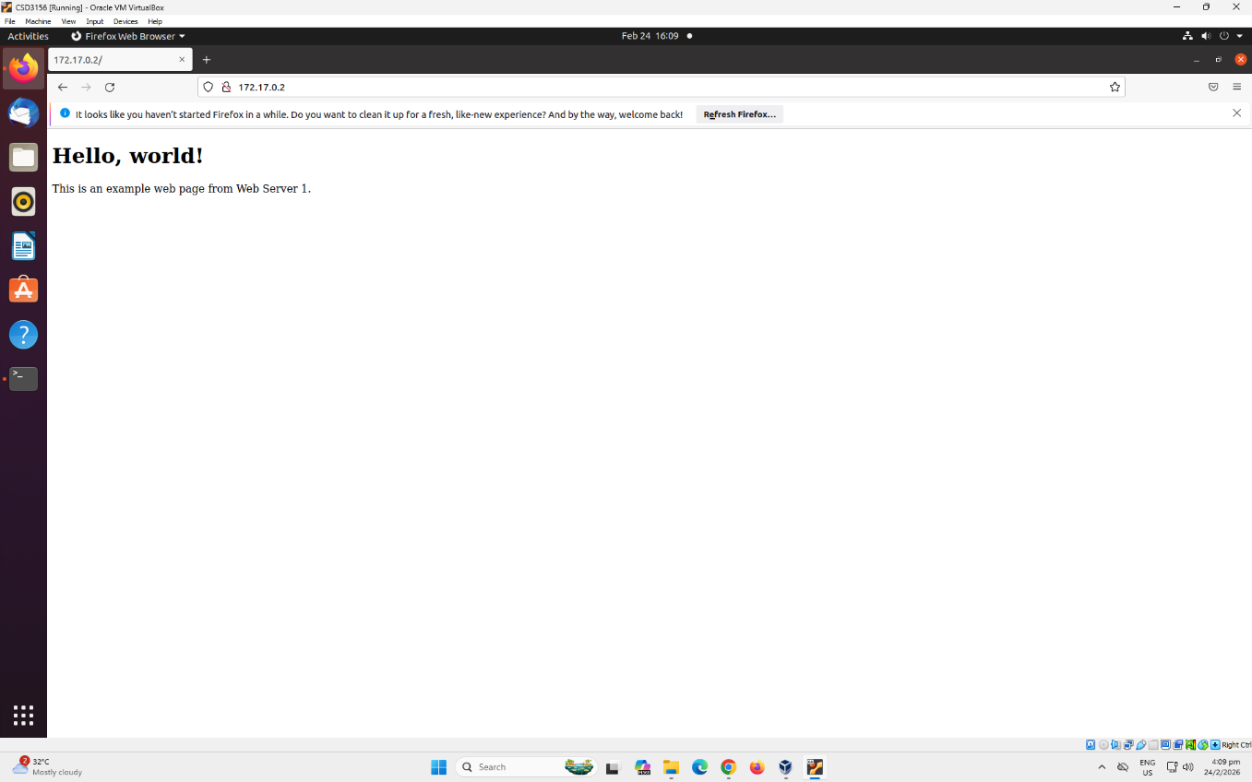

Result 3: Please paste the screenshot in the box below.
sudo docker run -d --name web2 myhttpd:v1
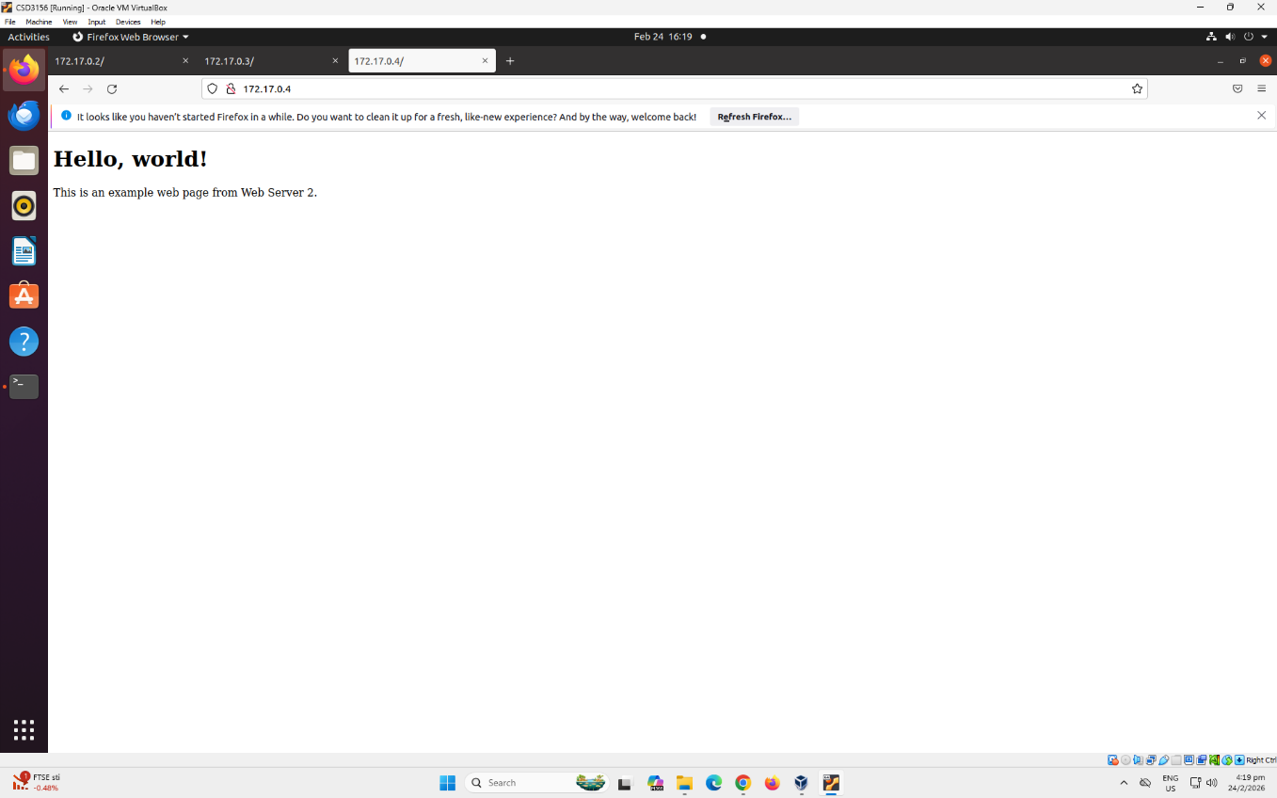

Reflection: Please add one or two lines on what you have learned.
Create/run docker containers, building docker images and interacting with a container.

